**Women in War – Australia**



***War Impacts in Australia:***

* Initially, lives of Australians not directly affected by fighting of the war
* After Japan entered, Australian population mobilised to support war effort
* Darwin Bombing saw Prime Minister Curtin declare a state of *total war*
* The Directorate of Manpower allowed government to allocate people to a particular industry to work

***Women before the War***:

* Women not permitted to join the military
* Some working women employed in factories, shops or family businesses
* Expected to resign from these positions when they fell pregnant

***Women During the War:***

* Beginning of war = women encouraged to support as they did in WWI (e.g. packing parcels, knitting, raising money, maintaining the home)
* Needs of the armed forces, the war economy and deployment of men overseas opened up new opportunities
* Only a 5% increase in female involvement in workforce between 1939 – 1945
* However, the types of work they performed was significant
* Late 1940: women were encouraged to join the services

***What roles did women play?***

* 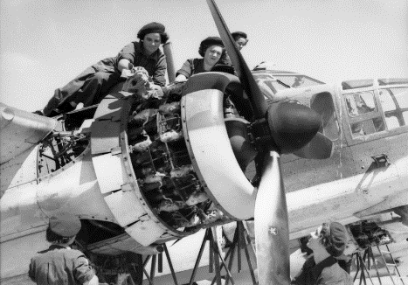Mostly clerical roles
* Some took men’s positions
  + Signallers
  + Truck and ambulance drivers
  + Intelligence officers
  + Aircraft ground staff
* As per the Directorate of Manpower, women could also be assigned to roles that suited their skillset

***Service Stats – Australia Women’s Service Group Numbers (WW2)***

*WAAAF – Women's Auxiliary Australian Air Force*

*AWAS – Australian Women's Army Service*

*WRANS – Women's Royal Australian Naval Service*

**Women in War – Source Analysis**

***Look at the sources and complete the tables. You will work as a class to complete the first one. Good luck!*** ☺



|  |  |
| --- | --- |
| **Source 1 – Maurice Bramley, ‘Join us in a victory job’, 1943** | |
| ***What is being promised?*** | An available job for to help in the war. |
| ***What sorts of jobs are being offered?*** | Nurse  Mechanic  Mechanic |
| ***Who is the target audience for these advertisements?*** | Women who are currently without jobs who are willing to help in the ware effort for money and an exciting time. |
| ***What words, images or ideas are used to ‘sell’ the promise of the advertisement?*** | Join us in a victory job  Implies successful contributions  Various women in various roles  All appear happy/confidant |
| ***How successful do you think the advertisement would have been? Why?*** | This would have been successful at convincing its audience to join the war effort. This is because of its appealing visual features including large bold text, a clear call to action and many happy women in their uniforms. |

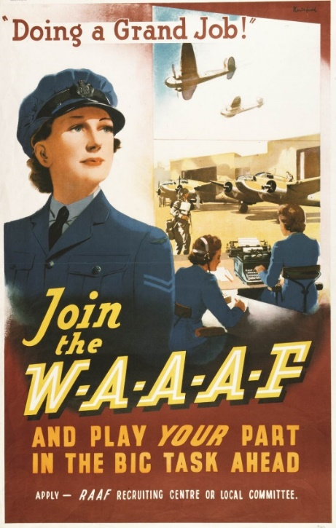

|  |  |
| --- | --- |
| **Source 2 – James Northfield, ‘“Doing a grand job!” Join the WAAAF’, 1942** | |
| ***What is being promised?*** | An available job in the women’s Australian axillary air force |
| ***What sorts of jobs are being offered?*** | A job in the air force, mostly jobs on the ground such as traffic control and ground signalling |
| ***Who is the target audience for these advertisements?*** | The audience is adventurous women wanting to help in the war effort and may have an interest in aviation. |
| ***What words, images or ideas are used to ‘sell’ the promise of the advertisement?*** | Doing a grand Job  Women doing their job in the air force  Join the WAAAF and play your part in the big task ahead |
| ***How successful do you think the advertisement would have been? Why?*** |  |

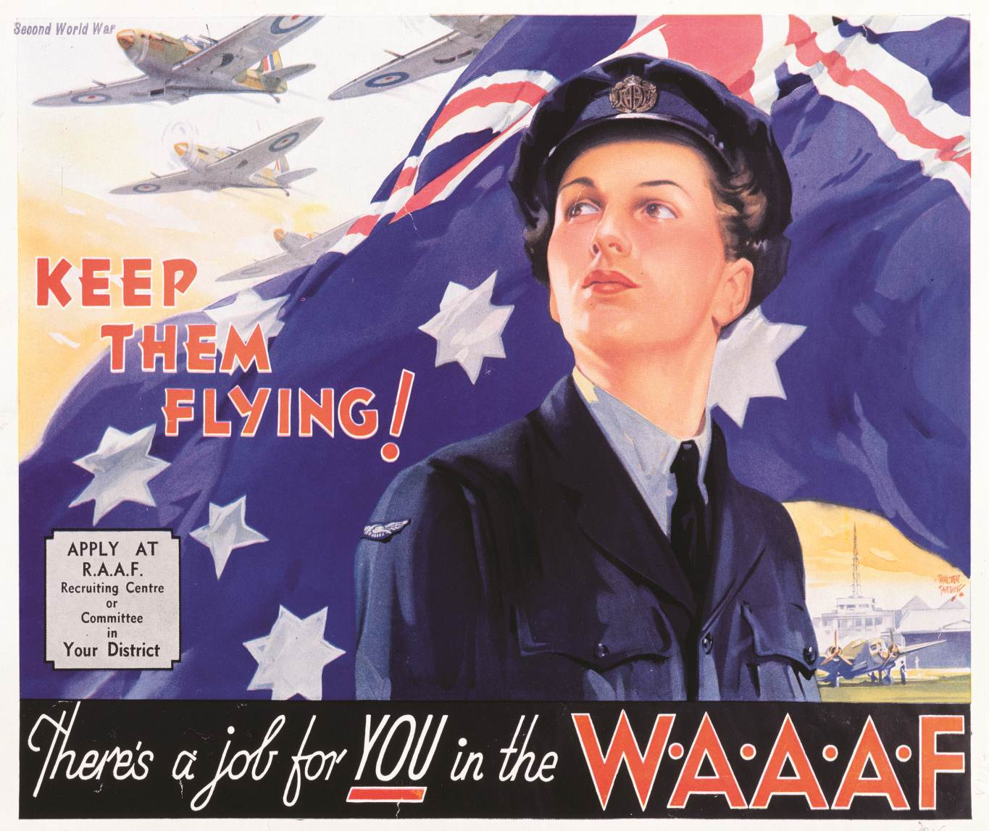

|  |  |
| --- | --- |
| **Source 3 – Walter Lacy Jardine, ‘Keep them flying!’, 1942** | |
| ***What is being promised?*** | A Job for you in the WAAAF |
| ***What sorts of jobs are being offered?*** |  |
| ***Who is the target audience for these advertisements?*** | Women who like to aid others compassionate and are seeking purpose. |
| ***What words, images or ideas are used to ‘sell’ the promise of the advertisement?*** | Woman Infront of Australian flag  Planes flying overhead  Keep them flying  Call to action  Underlined you |
| ***How successful do you think the advertisement would have been? Why?*** |  |